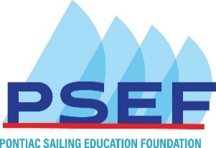
Junior Sailing Fundraiser: Semi-Virtual Cheese, Chocolate, and Beer Tasting
- Organize your party small group
- Email back this completed form as an attachment to dbsanders1979@gmail.com
- Complete payment via PayPal or check (details below).
- Pick up your Party Pack between 11am – 3pm on Saturday, December 5 at the Sailing Center, 3260 Orchard Lk Rd, Orchard Lake
- Click on Zoom link sent via email on Dec 5 at 7pm
If you have questions, please call or text Bill Sanders at 248-420-0965
Limited Supplies. Reserve your Pack ASAP
First + Last Name:
Address:
Email:
Phone:

Order your 4-person party tasting pack:
Description: 8 12oz bottles of 4 kinds of New Belgium Winter beer/ ale
29 oz cheese flight of Cheddar, Iberico, Chevre, Fontal, Pecorino Toscal
9 oz of 12 varieties of Gudrun Belgian Chocolate (18 pieces)
16 oz of 2 varieties of Carr’s Table Water crackers
 |  | Cost /order | # orders | Total
 | 4-person party pack | $200.00 | 1
 | 1 Raffle ticket | $5.00
 | 5 Raffle tickets | $20.00 | 10
 | Total amount due:

For an Additional $200.00, Become a Sponsor
 | For every additional $200, receive a paired wine! | Sponsored Amount | # Bottles
 | Sponsor names will be displayed during the event

Payment
PSEF is a 501(c)(3) charitable organization. Tax ID#38-2559458
- PayPal at www.psef54.org/donate.
- Check payable to Pontiac Sailing Education Foundation.
Please mail check to the PSEF Treasurer: PSEF: Tasting
PO Box 430594
Pontiac MI 48343
Thank you for your generous support of junior sailors!

